Asia-China-Coin-Yuan Dynasty (1280-1368)-Emperor Temur Oljeitu (1294-1307)

SHAPE \* MERGEFORMAT 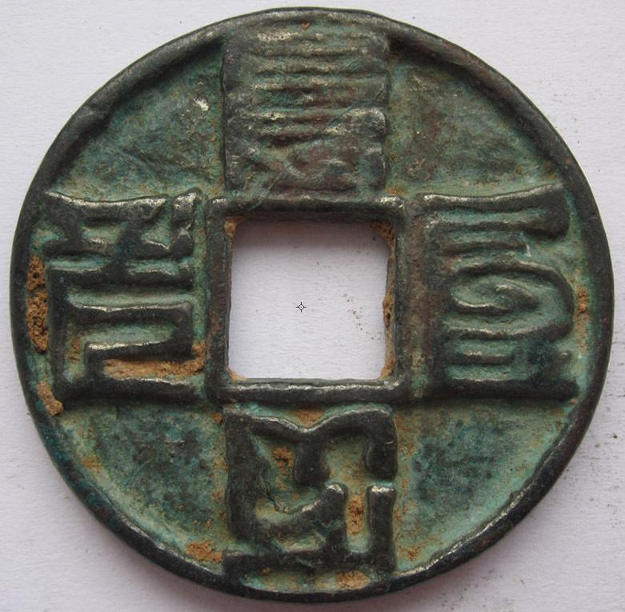

Yuan Dynasty (1280-1368)-Emperor Temur Oljeitu (1294-1307), Obv.: (Mongol) Ta De tung Baw = Da De tong bao (1297-1307), 3 cash size coin, H 19.27, FD 1720, R 2. Da De was also a Western Xia title.

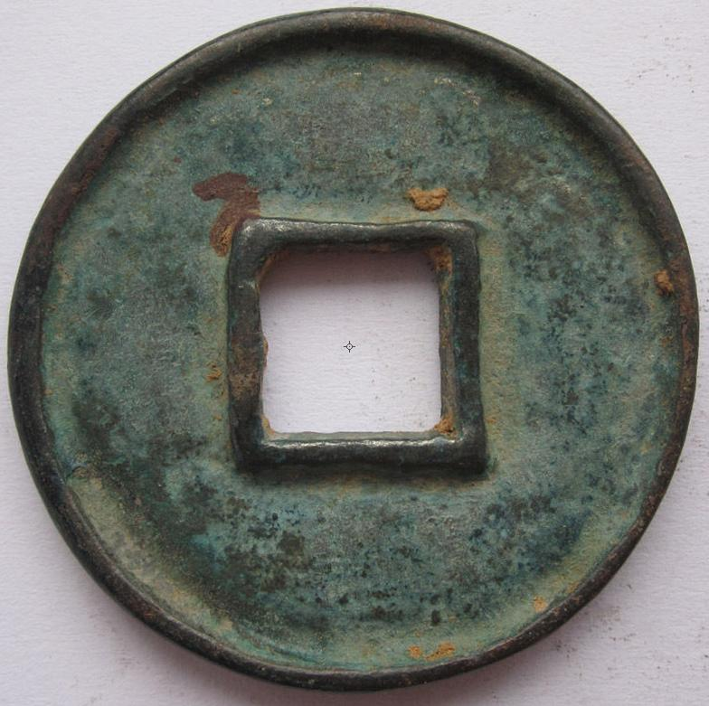

Order details Printer friendly page

Sold by

[linzhoulin](http://myworld.ebay.com/linzhoulin) ( [3118](http://feedback.ebay.com/ws/eBayISAPI.dll?ViewFeedback&userid=linzhoulin)  )

+ Show additional actions

Delivery package 1 of 1

Estimated delivery Friday, Jan 17, 2014 - Friday, Feb 14, 2014

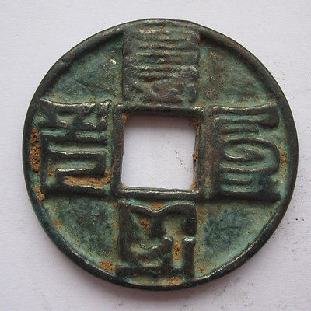

[China "Unknow" Coin 070110](http://www.ebay.com/itm/161182912744)

Item price

$29.99

Quantity

1

Item number

161182912744

Shipping service

Economy Shipping from outside US

[Leave feedback](http://feedback.ebay.com/ws/eBayISAPI.dll?LeaveFeedbackShow&useridfrom=802-867&useridto=linzhoulin&item=161182912744&transactid=0) [Contact seller](http://contact.ebay.com/ws/eBayISAPI.dll?FindAnswers&frm=3998&iid=161182912744&redirect=0&requested=linzhoulin) [Return item](http://return.ebay.com/ws/eBayISAPI.dll?ResolveReturn&eventName=viewSelectedItem&TransactionId=0&ItemId=161182912744)

### Shipping address

Ralph J Coffman Jr  
149 Atlantic Ave   
Swampscott MA 01907-2427  
United States

Phone number  
781 584 7091

### Order total

Subtotal $29.99

Shipping Free

#### Total

## $29.99

[View PayPal transaction](http://payments.ebay.com/ws1/eBayISAPI.dll?IntermediateResolutionInfo&itemid=161182912744&transId=0&pn=UnifiedCheckoutSummaryRedirect2PP&qs=itemid%3D161182912744%26transId%3D0%26buyerorseller%3D0%26)

### Order information

Order placed on  
Monday, Dec 30, 2013

Having a problem with this purchase?  
[Resolve problem](http://res.ebay.com/ws/eBayISAPI.dll?ResolutionCenter)

Payment method   
PayPal

Payment date  
Monday, Dec 30, 2013